LTSpice Hierarchical Design

I talked in the meeting about making a simulation for the Geec that can be expanded as need. Here’s a quick guide to how to make a hierarchical model in LTSpice (I’ve just spent the last 2 hours hitting my head against the wall for different parts).

Goal
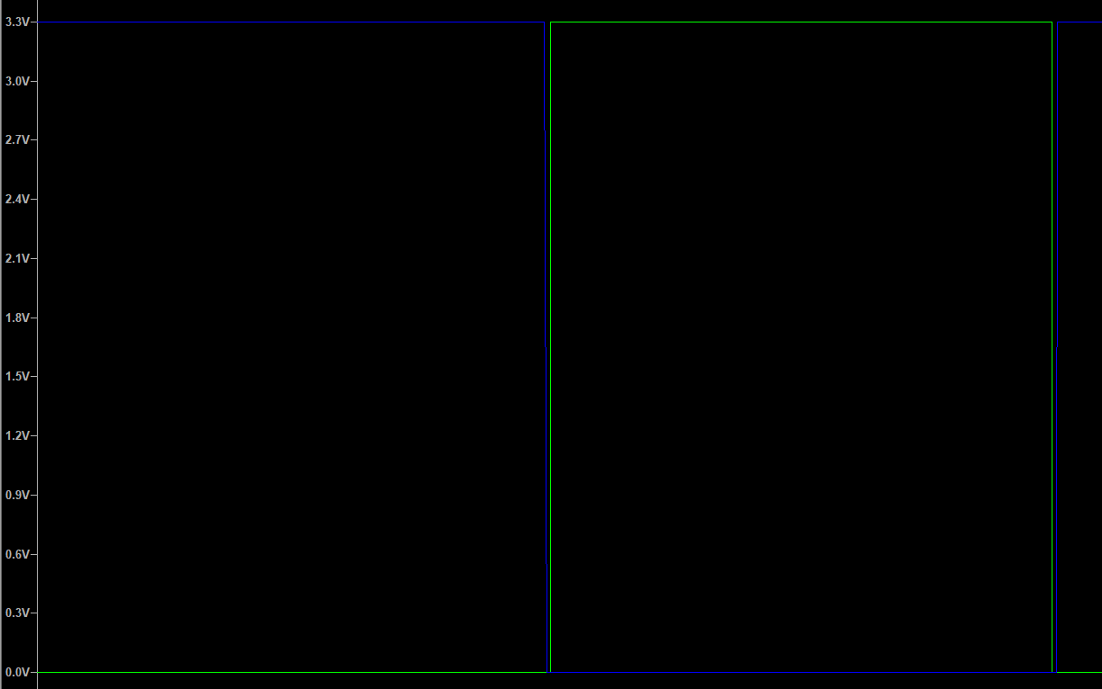
The goal for this part is to create a PWM generator, that will separate the high and low output signal by a short period of time (called Deadtime). This Electronic Stack Exchange question details how the schematic should look.
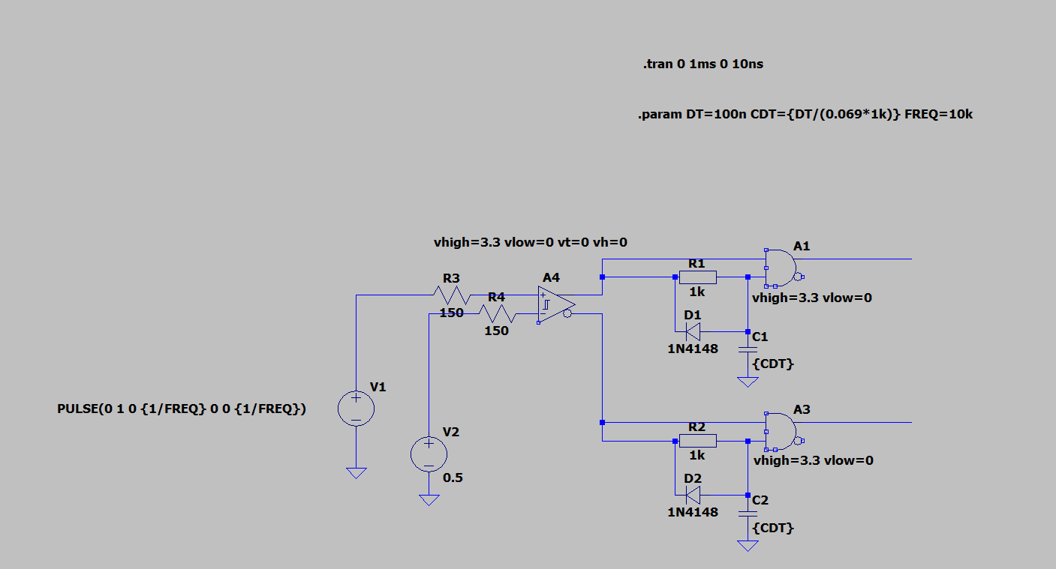
Here’s my implementation. V1 is a sawtooth wave, starting at 0V and going to 1V over a time of 1/FREQ. This connects to a comparator, where if V+ is greater than V- the output will be high. V2 connects to V- and sets the low limit.
Copy that file or create your own similar file. This one is called “PWMGen.asc”
FREQ is defined using the .PARAM SPICE directive.
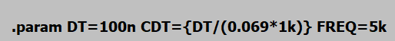

Method

Replace inputs and outputs with net labels
In our case V2 should be replaced with an input pin that can go from 0-1V. Delete V2 and add a net label

Change the Port Type to input/output and change the name to something appropriate like Vset.
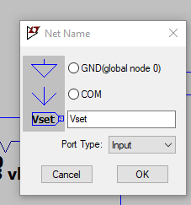
Repeat for PWMH and PWML
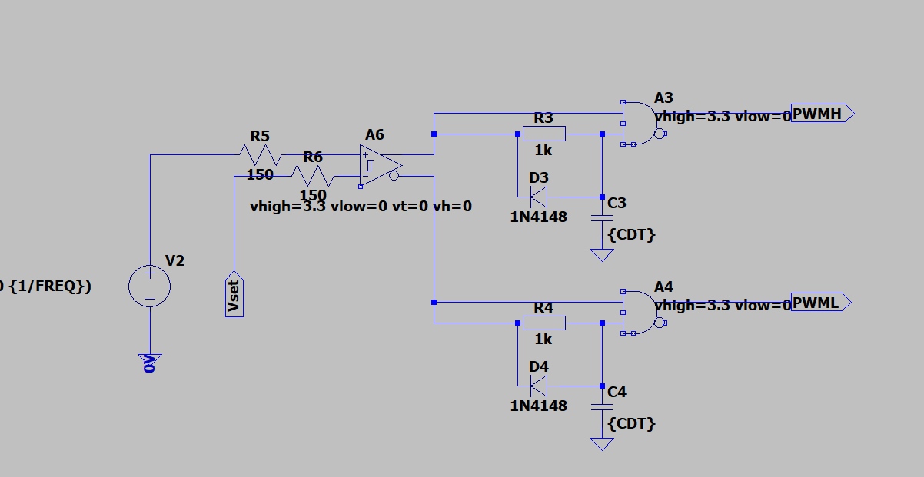
Resulting circuit should look like this.

Create a Symbol
Open or Generate this Sheet’s Symbol
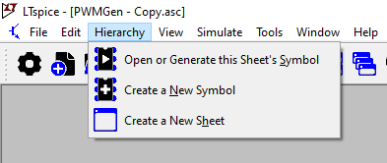
If you’re just creating a symbol a menu will appear, click Yes./
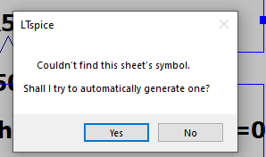
The auto generated symbol will appear like so:
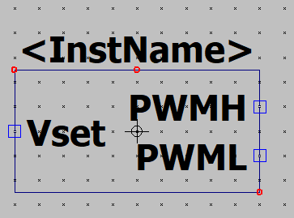
This is a little non-descript, so you can use the Draw menu to add some description or details to the symbol. I modified my symbol to look like so:
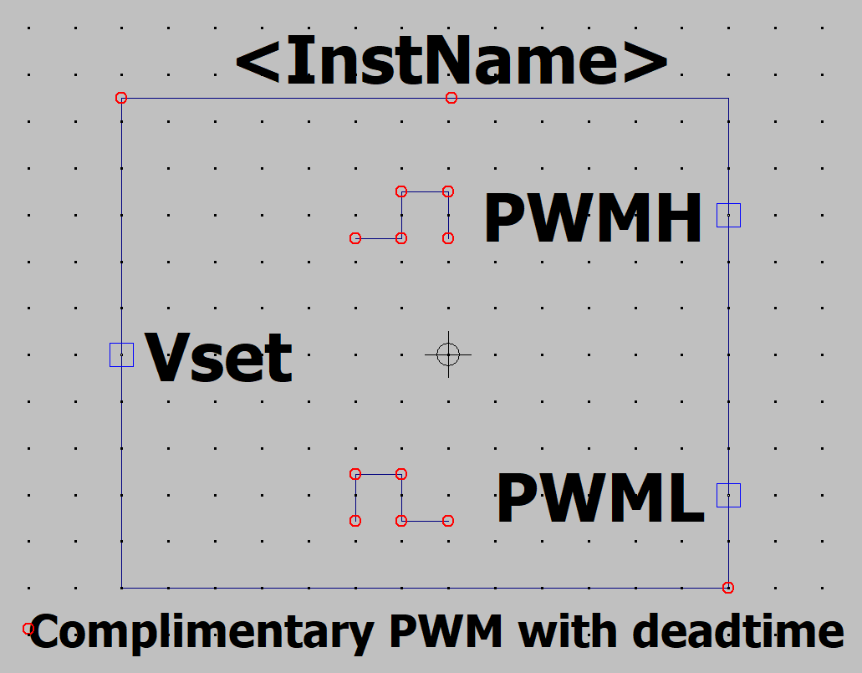

Importing into a new schematic
To add this block into a new schematic in LTSpice, create a new schematic in the same directory as the file created above. Add a part (shortcut P or the chip symbol in the hotbar).
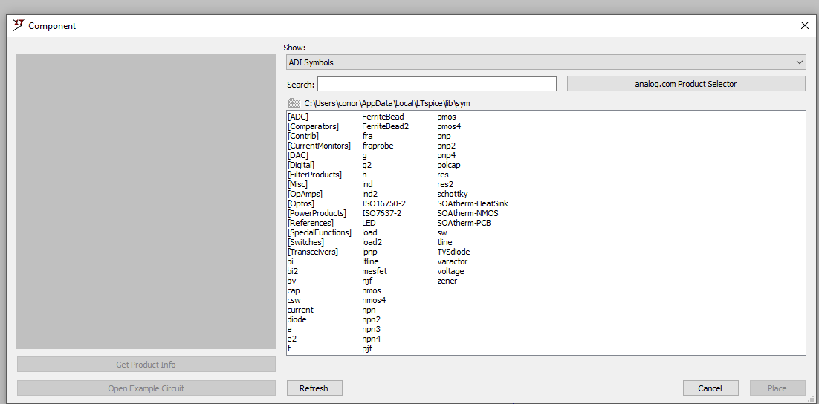
A menu like above will appear,
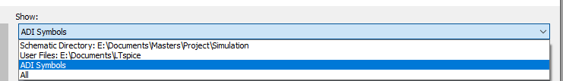
Change the Show menu to schematic directory.
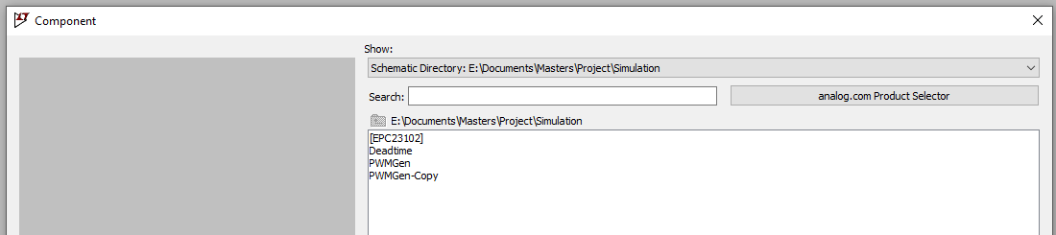
The part designed above should be available to add. You can then add the part to you schematic. I created this simple test schematic:
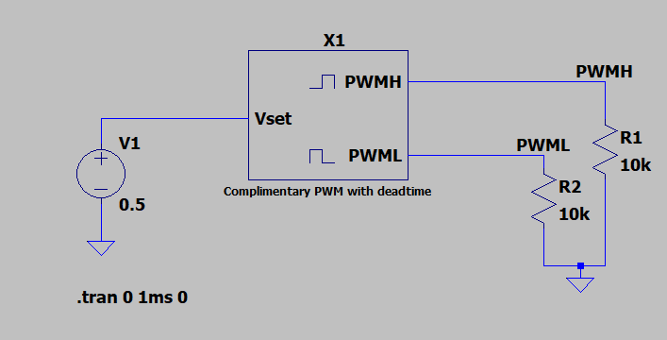

Which created the following graph:
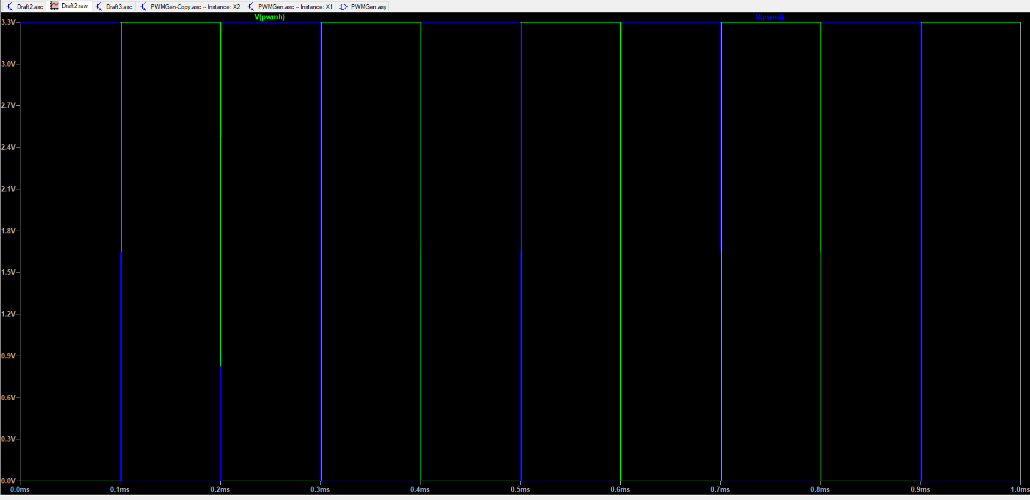

To keep files clearer you can also move the blocks to sub folders and still import them into LTSpice
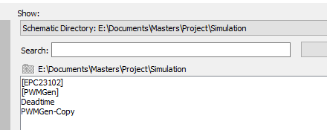
You need to move the symbol and schematic file into the sub folder i.e. “PWMGen.asc” & “PWMGen.asy”.

